**IVAN CHARLES LOBO**

6th Dec.1977

Address: A/16, 202, Veena Nagar No.2, L.B.S Marg, Mulund West, Mumbai 400 080.

Mob: 8879353482 / Res: (022) 21644385 / E-mail: ivan_lobo1@yahoo.co.uk

**PROFESSIONAL SUMMARY**

 Enthusiastic and pro-active Software Engineer, Architect and Individual Contributor with over 12 years of experience, designing and developing applications using the .net framework.

 Strong knowledge of OOD, SOA, .NET, Architectural design, Web Development and Database Architecture with experience in developing and implementing Enterprise based applications.

 Creative, talented, versatile, process-oriented and competent with a high customer orientation and takes great pride in exceeding expectations and beating deadlines.

 Excellent communication, interpersonal, research/analysis, organizational skills and client facing experience.

 Strong leadership and team player qualities demonstrated in mentoring individuals to maximize level of productivity and form cohesive team environments.

**OBJECTIVES**

Currently seeking a new and challenging position, one that will make best use of existing skills and experience whilst enabling further personal and professional development.

**TECHNICAL SKILLS**

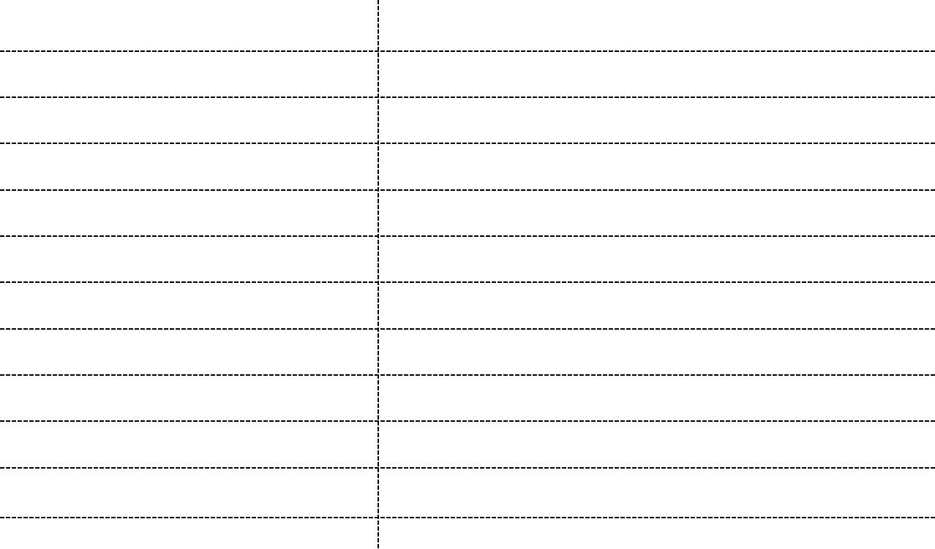

**LANGUAGES** C# .Net

**DATABASE** SQL Server 2008R2, Azure Storage

**WEB BASED** Asp.net MVC, Asp.Net, Web API 2.0, WCF

**CLOUD** Azure (PaaS & IaaS)

**SCRIPTING LANGUAGES** Javascript, JQuery, AngularJs2.0

**VERSION CONTROL** Team Foundation Server, SVN

**WEB SERVERS** IIS 7.0 & above

**CODE-METRIC TOOLS** FX-Corp, StyleCorp

**CONCEPTS** OOAD/OOD(Design Patterns), TDD

**OTHER TOOLS** NUnit, N-Ant, XMLSPY, Re-Sharper, MS-Test

**EMPLOYMENT HISTORY**

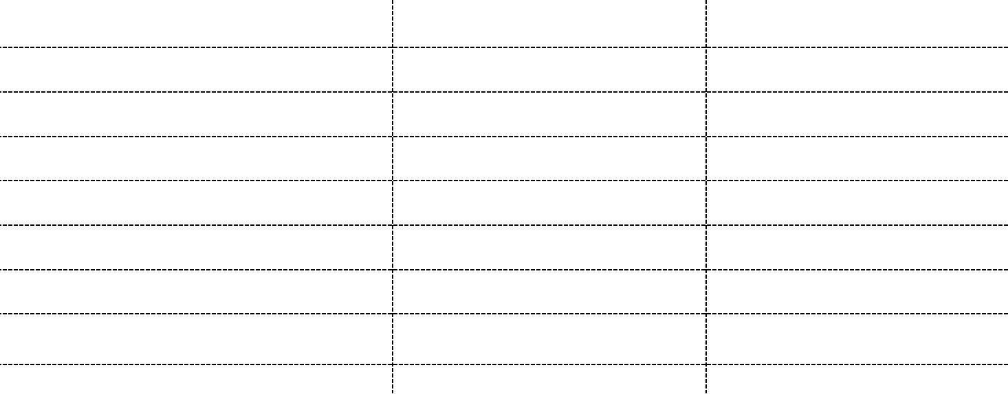

|  |  |  |
| --- | --- | --- |
| **EMPLOYER** | **DESIGNATION** | **DURATION** |
| Sterling Backcheck | Technical Architect | Mar 2015 - Nov 2015 |
| Capgemini India Pvt. Ltd | Sr. Consultant | Jan 2013 - Sep 2014 |
| Datamatics Global Services | Sr. Consultant | Oct 2010 - Apr 2012 |
| Blue Star Infotech | Sr. Developer | Nov 2008 - Aug 2010 |
| Infrasofttech | Sr. Developer | Feb 2007 - Oct 2008 |
| Aurion-Pro Solutions Ltd. | Sr. Developer | Jan 2005 - Jan 2007 |
| Genesis Online Systems | Developer | Jun 2004 - Dec 2004 |
|  |  |  |

**INTERNATIONAL EXPERIENCE**

|  |  |  |  |
| --- | --- | --- | --- |
| **CLIENT** | **LOCATION** | **ROLE** | **DURATION** |
| Schlumberger | USA(Houston, TX) | Lead & Architect | Nov 2013 - Dec 2013 |
| United Nations(IAEA) | Austria(Vienna) | Architect | Oct 2010 - Dec 2011 |
| Grass Roots | UK(business trip) | Tech. Lead | Short term |
| Charities Aid Foundation(CAF) | UK(Work Permit) | Sr. Developer | Dec 2007 - Aug 2008 |

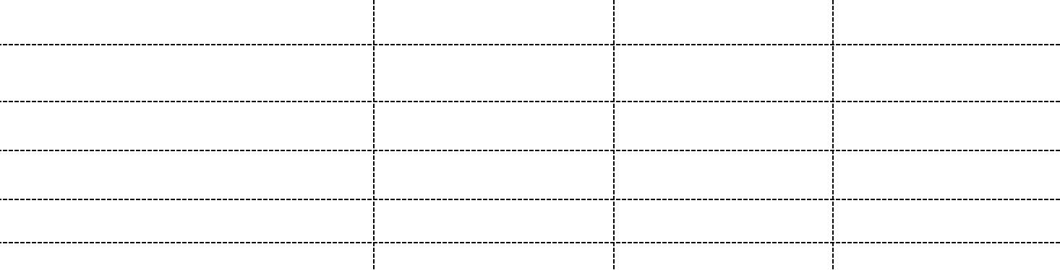



***Currently holding a US B1 VISA valid upto Oct 2023 under Passport No: K4542588***

**EDUCATIONAL QUALIFICATION**

|  |  |  |  |
| --- | --- | --- | --- |
| **DEGREE** | **SPECIALISATION** | **YEAR OF PASSING** | **UNIVERSITY** |
| M.B.A | Information Technology | Aug 2012 - Nov 2014 | Sikkim Manipal |
| Bachelor of Science | Chemistry | Apr 1999 - May 2000 | Mumbai |
| NCST | Technology | Participated | C-DAC |

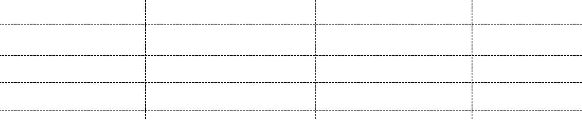

SIONAL EXPERIENCE

**Client:** Sterling Backcheck

**Project:** PRISM-Public Records Integration and Smart Mapping

**Employer:** Sterling Backcheck.

*February2015 – November2015.*



**OVERVIEW**



Prism is an Azure Cloud based asynchronous application for automated fulfillment of Criminal and civil searches. This multi-layered, multi-tiered application connects to various third party court websites and Web Services and is responsible for fetching case data. The data thus fetched is then processed and formatted using an in-built rule engine having rules set in the HRXML format and published back to the source application.

Prism is built extensively on Windows Azure (Paas) and uses Topics-Subscriptions and Micro-Services

for improved scalability, availability and better performance.



**DETAILS**



**Designation:** Dotnet Architect (Grade : G3-L1)

**Role:** Technical Architect & Lead

**Team Size:** 20

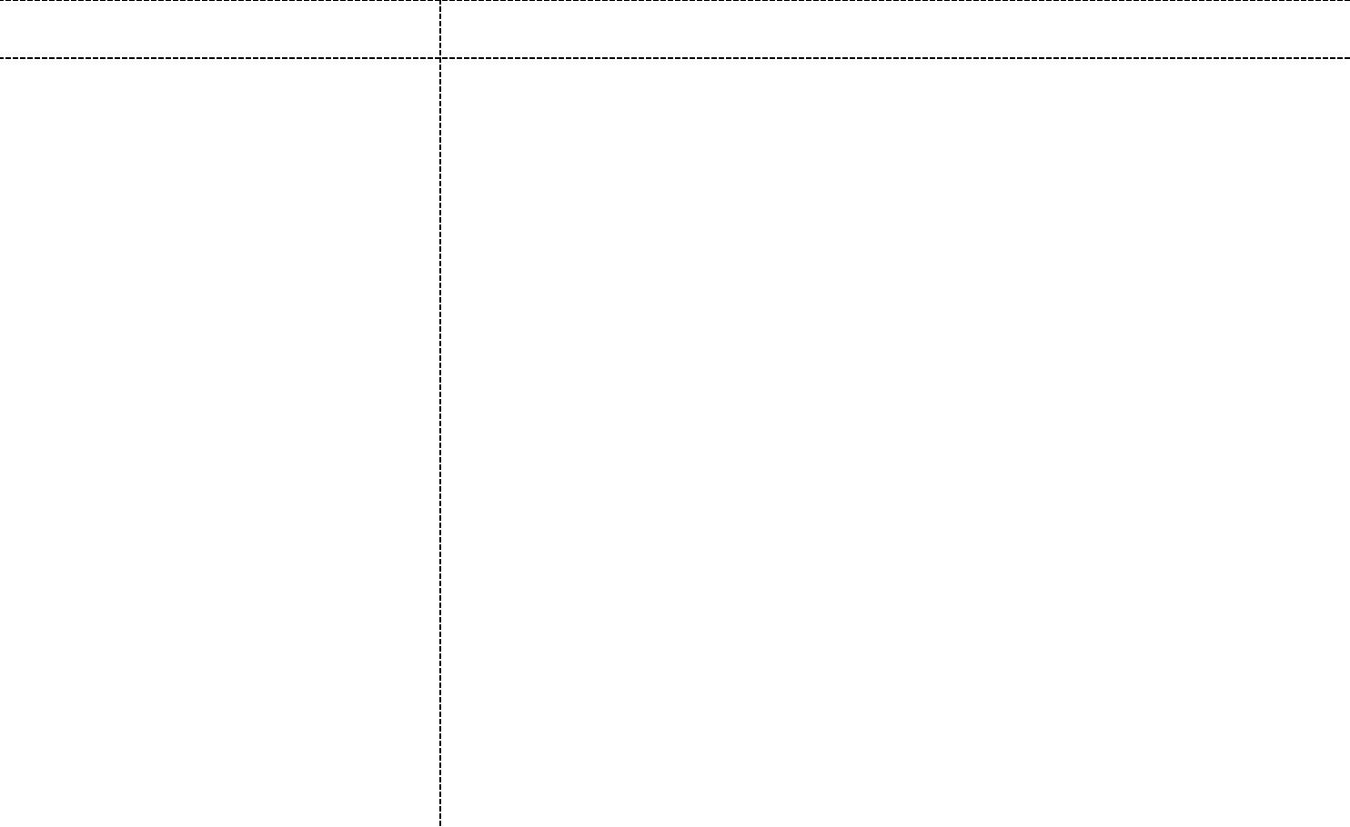

**TECHNOLOGIES** **RESPONSIBILITIES**

|  |  |
| --- | --- |
| * VS 2015 * Windows Azure (Paas) * ASP.NET.Net MVC 5.0 * Entity Framework 6.0 * Web API 2.0 * MongoDB * Sql Server 2008 R2 * Team Foundation Server * Aurelia * Jenkins * Octopus * Autofac * AutoMapper * NUnit * Moq * Visio * Jira Agile | Designed and Architectured the brownfield application using  a resource oriented architectural approach and Azure Cloud  (Paas).  Designed the middle-tier of the application for message  exchange using the Azure Service Bus (Pub/Sub) middleware.  Designed and developed the core middle-tier framework of the  application for data persistence to MongoDb and  Sql server using OOAD design patterns.  Designed the interface for monitoring the application pulse  using a mean stack js framework like Angularjs2 and MVC 5.  Created resource oriented interface facades to seamlessly  interact with highly-reliable and asynchronous cloud  messaging bus for easy transmission of business processes  between existing brownfield application and Azure Cloud App  Service.  Created the application architechtural blueprints using  Visio templates and ADD Iterative cycle.  Conducted technical trainings to mentor team members on  new technologies and designs workflows.  Used tools for Performance Monitoring and Code reviews.  Resourcefully served as the facilitator and contributor for  developing applications using Agile Scrum. |
|  |  |

**Client:** Schlumberger

**Project:** Field Ticket Light (FTL)

**Employer:** Capgemini India Pvt. Ltd.

*January 2013 – September 2014*



**OVERVIEW**



Schlumberger is the world’s leading supplier of technology, integrated project management and information solutions to customers working in the oil and gas industry worldwide. Employing approximately 126,000 people representing over 140 nationalities and working in more than 85 countries, Schlumberger provides the industry’s widest range of products and services from exploration through production. This n-layered, n-tiered web-enabled and SOA based enterprise system is developed using modern technologies and is used by Schlumbergers Field Engineers & FSM (Field Service Managers) for logging & tracking the Oil Field Services & solutions provided to their respective Clients. FTL is part of the enterprise e-sales application suite that comprises of ComCat, FTL-Rig and eZview and serves as a data hub for different enterprise based legacy systems like SAP, Siebel, J2EE and Lawson for ticketing, incident reporting, bonus calculations, accounting and invoicing. A centralized and normalized database system RAVI supports the recording and maintenance of historical data for data warehousing using Business Intelligence tools like SSRS and SSIS.



**DETAILS**



**Designation:** Sr. Consultant

**Role:** Tech Lead, Architect & Individual Contributor

**Team Size:** 20 (global)



**TECHNOLOGIES** **RESPONSIBILITIES**

• VS 2013  Part of the pilot team that interfaced with the client to understand

• ASP.NET.Net MVC 4 .0 & 5.0 technical and functional requirements of the existing system.

• Entity Framework 6.0  Involved in the complete transition and knowledge transfer

• Web API process of the system from the previous vendor.

• Sql Server 2008 R2  Created system overview documents and presentation slides.

• Team Foundation Server  Designed and developed the architectural flow (n-Tier

• SSRS & n-layered) using design frameworks tools like Asp.net MVC,

• Ms-Test Entity Framework, Ajax and jQuery.

• jQuery 2.0  Designed, Developed and Implemented ROA based architecture

• Ajax using Rest based Web API.

• AutoFac  Designed and developed database objects and schemas.

• jQGrid Involved in the development of Single Sign On application.

• Windows Service  Used Agile FDD methodology and ALM tool to manage the

• Serena ALM team's software development lifecycle.

• Agile,Scrum  Developed the application architecture towards a TDD approach

• Web Farm using MS-Test.

• IIS 7. 5  Coordinating with team members to achieve client deadlines.

• Azure(Iaas & Paas)

**Client:** IAEA (United Nations) Vienna, Austria

**Project:** Safeguards Quality Management System (SGQMS)

**Employer:** Datamatics Pvt. Ltd.

*October 2010 – April 2012*



**OVERVIEW**



The Department of Safeguards is the organizational hub for the implementation of IAEA safeguards. The IAEA implements nuclear verification activities for more than 175 States in accordance with their safeguards agreements. The Department of Safeguards’ Quality Management System (QMS) requires that all established policies, processes and procedures are documented in a cont rolled manner, fulfilling the requirements of the management standard ISO 9001. The aim is to unify the various document control systems in place such as the Safeguards Manual, Authorized Instrument Information System (AIIS), Safeguards Technical Reports (STR) series and numerous ‘semi-officially’ published information on the Safeguards Intranet. The system aims at improving the user experience by reducing the number of required interactions which is viably important for document co-ordinators while updating active documents in the store.



**DETAILS**



**Designation:** Sr. Consultant

**Role:** Tech Lead, Architect & Individual Contributor

**Team Size:** 3



**TECHNOLOGIES** **RESPONSIBILITIES**

• VS 2010  Designed and developed the architectural flow

• ASP.NET.Net MVC 3.0 (n-Tier) using design frameworks tools like Asp.net

• Entity Framework (LinQ) MVC 3.0, Entity Framework and jQuery.

• WCF  Developed and Implemented SOA architecture

• Sql Server 2008 R2 using WCF services.

• Re-Sharper  Developed a report suite using the SSRS reporting

• StyleCorp web service framework.

• GitHub  Implemented code metric tools to provide

• SSRS solution-wide static code analysis and optimization.

• Nunit  Coordinated with the SafeGuards Business Team to

• jQuery1.4 analyze and integrate functional requirements.

• Ajax  Designed and developed database objects and

• Live-Link schemas.

 Integrated and developed the architecture to enable

test driven development.

 Managed deployment and versioning of client

deliverables using TFS and Agile Methodologies.

 Managed collaboration with other team members.

**Client:** Grass Roots, UK

**Project:** FlexSimple

**Employer:** BlueStar Infotech Pvt. Ltd.

*June 2009 – August 2010*



**OVERVIEW**



Flex Simple (Flexible Benefits scheme) offer employees an element of choice about the benefits they take by providing an allowance, and let employees pick from a range of benefits, with very few restrictions. Flex Simple offers a core package to employees, by including tax-efficient benefits such as cost-effective off-the-shelf solutions, child care vouchers, mobile phones, dental and also environment friendly schemes like bikes and carbon. This multi-tenant system is integrated and deployed on a web farm. Authentication of the users is achieved using custom built Single Sign On authentication system using web services.



**DETAILS**



**Designation:** Sr. Consultant

**Role:** Tech Lead, Architect & Individual Contributor

**Team Size:** 5 (global)



**TECHNOLOGIES** **RESPONSIBILITIES**

• VS 2010  Part of the pilot team that interfaced with the client to understand

• ASP.NET.Net MVC 3.0 and gather functional requirements.

• C#  Designed and developed the architectural framework (n-Tier)

• Entity Framework (LinQ) using design frameworks tools like Asp.net Web Forms,

• WCF Asp.net MVC 3.0, Entity Framework and jQuery.

• Sql Server 2005  Designed the architecture to enable the deployment and functioning

• ReSharper of the website on a web farm.

• StyleCorp  Developed and integrated GPASS system for authenticating users

• Tortoise Svn using in-house single sign on.

• SSRS  Designed the website using concepts like dynamic css and theming.

• CSS 2.1  Implemented code metric tools to provide solution-wide static code

• NUnit analysis and optimization.

• jQuery1.3.1  Coordinated with the onsite team to analyze and integrate functional

• Web Farm IIS7.0 requirements and create low level design.

• Windows Server 2008  Designed and developed database objects and schemas.

|  |
| --- |
| Used Agile SCRUM process and TFS to manage the team's software  development lifecycle.  Designed and developed application components towards a  TDD approach using MS-Test and Mocks. |
|  |
|  |
|  |

**Client:** Oxfam, UK

**Project:** Helios- Oxfam

**Employer:** BlueStar Infotech Pvt. Ltd.

*November 2008 – June 2009*



**OVERVIEW**



Oxfam is an international confederation of 17 organizations working in approximately 94 countries worldwide to find solutions to poverty and what it considers as injustice around the world. The HELIOS software is a comprehensive supply chain technology solution that brings order to disaster relief, helping humanitarian organizations provide aid to people quickly and more efficiently. HELIOS provides real-time access to supply chain information to enhance decision-making at every level throughout the aid delivery process, from leading international non-governmental organizations (NGOs) for a "next generation" supply chain management software to enable them to effectively track the myriad of goods and donations entering and being disbursed across the communities affected by natural calamities.



**DETAILS**



**Designation:** Sr. Developer

**Role:** Lead Developer

**Team Size:** 22



**TECHNOLOGIES** **RESPONSIBILITIES**

|  |  |
| --- | --- |
| • VS 2010 | Designed and developed Stock Disposal module |
|  |  |
| • ASP.NET.Net 3.5 | using Asp.net Web Forms, Entity Framework and jQuery |
|  |  |
| • Entity Framework (LinQ) | Involved in Requirement analysis and design. |
|  |  |
| • Ajax | Designed and developed the architectural framework |
|  |  |
| • WCF | (n-layered) using design frameworks tools like Asp.net Web |
|  |  |
| • JQuery | Forms, Asp.net MVC 3.0, Entity Framework and jQuery. |
|  |  |
| • JSon  • SQL Server 2008R2 | Independently developed custom reusable components  using Sql server and SqlDmo object |
|  |  |
|  |  |
| • Fx-Corp | Designed and developed database objects and schemas. |
|  |  |
| • TFS 2008 | Implemented code metric tools to provide solution-wide |
|  |  |
|  | static code analysis and optimization. |
|  |  |
|  | Used Agile SCRUM process and TFS to manage the team's |
|  |  |
|  | software development lifecycle. |
|  |  |
|  | Designed and developed application components towards a |
|  |  |
|  | TDD approach using MS-Test and Mocks. |
|  |  |
|  | Managed collaboration with other team members to achieve |
|  |  |
|  | client deadlines. |
|  |  |
|  | Involved in Troubleshooting and defect fixing |

**Client:** Charities Aid Foundation(CAF)

**Project:** CAF Direct Online, UK

**Employer:** InfraSoft Technologies

*December 2007 – October 2008*



**OVERVIEW**



CAF Bank provides simple and straightforward day-to-day banking, designed exclusively for charities. This system is developed to facilitate online money transfers to other CAF Bank accounts and nominated accounts with single authority. It also has the facility to manage and amend Direct Debits and standing orders online. It offers comprehensive and tailored donor management and fulfillment services, appeals management and e-fundraising services.



**DETAILS**



**Designation:** Sr. Developer

**Role:** Team Lead

**Team Size:** 10



**TECHNOLOGIES** **RESPONSIBILITIES**

|  |  |
| --- | --- |
| • .NET 2.0  • C# | Designed and developed “give as you earn” module using  Asp.net Web Forms. |
| • ASP.NET | Designed and developed Soap web services. |
| • ADO.NET  • Visual Source Safe  • SQL Server 2005 | Designed and developed database objects and schemas.  Designed and developed application components towards a  TDD approach using NUnit. |
| • IIS5.0  • Web Services (Soap)  • Fx-Corp | Independently interfaced with the client to gather functional  requirements and analyzed them to make the technical and  architectural layout. |
| • Nunit | Build packaged and deployed the application using NAnt. |
| • NAnt | Implemented code metric tools to provide solution-wide  static code analysis and optimization. |
|  | Independently handled team management and also involved  in troubleshooting, unit testing and defect fixing. |
|  |  |
|  |  |
|  |  |

**Project:** Arig (Arab Insurance Group)

**Employer:** InfraSoft Technologies

**Designation & Role:** Sr. Developer

**Team Size:** 22

*February 2007 – November 2007*

**Overview:** This application provides end to end solution for internal Investment Management and includes wide variety of investment products like Deposits, fixed income, Bonds, Equities, FX, Money Market, etc. This system supports real time transaction with multi channel and multi currency support connected to market data for up to date script information following the local accounting standards. The solution provides an ASP.net based user interface for all the modules mentioned in requirements. Portfolio creation, asset data fetching from Bloomberg, deals creation and deals work flow management are handled efficiently and accurately in this solution. Deals settlement, Accounting and transaction,deal advice creation and all other back office activities are handled efficiently. The solution is designed to handle multiple co-current user access with faster information delivery and fine data integrity.

**Project:** Arpan V2.0

**Employer:** AurionPro Solutions

**Designation & Role:** Developer

**Team Size:** 30

*January 2005 – January 2007*

**Overview:** This customized application software is a Record Office Automation Suite designed and developed for the Indian Army and is installed at 45 record offices of the Indian Army. This application suite automates various processes of the army record office such as Updation, Enrollment, Promotion, Posting, Family Allotment, Manpower, Part to Order, Sheetroll, Planning, ACRs, Pension, Effective and Non-effective records.

**Project:** Dolphin Logistics

**Employer:** Genesis Online Technologies

**Designation & Role:** Developer

**Team Size:** 10

*June 2004 – December 2004*

**Overview:** This ERP is a very comprehensive software typically suited for the NVOCC/MTO operator,Freight Forwarders, Forwarders with Nominated Cargo & Consolidators.

*January2016 – September 2016*

**Overview: Worked on a freelance project with AngularJs and Azure Cloud(Paas).**